## ADP Workforce Now

## **Essential Time & Attendance Employee Basics:**

## **For Exempt Employees**

**Overview**

This job aid guides you through some of the basic Time & Attendance tasks that you will complete. **As an exempt employee, use ADP Time & Attendance for only reporting leave time taken.**

You must have access to ADP Workforce Now with a username and password to complete the tasks described in this job aid. This training includes U.S. spellings and the date construct of month/day/year. You will see your expected spellings and date constructs in your solution back on the job.

**Accessing Learning Bytes in ADP Workforce Now**

Learning bytes are short demonstrations that show you how to perform specific tasks. A narrator describes the processes, highlighting key points. These learning bytes will support you with the help you need, right when you need it. Learning bytes are available on many pages throughout ADP Workforce Now. This procedure describes how you can access the learning bytes relevant to your timecard.

**Starting Point: Myself > Time & Attendance > My Timecard**

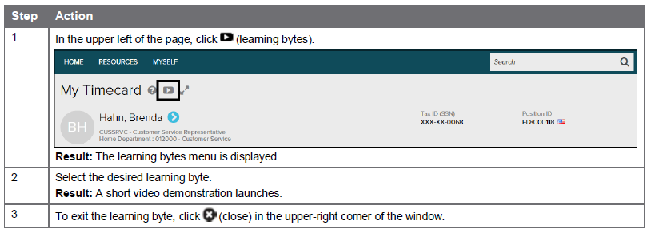

**Logging out of ADP**

**Starting Point: Top left hand corner of your screen**

Beside your name is an icon with an arrow pointing to the right. Click on this icon to log out of ADP.



**Viewing Your Timecard**

When viewing an exempt employee timecard it will be blank. Only time off/leave is to be reported in exempt employee timecards. By default, you will view the Current Pay Period. You can change this to Previous Pay Period or Range of Dates using the fields available at the top of the timecard.

**Starting Point: Myself > Time & Attendance > My Timecard**

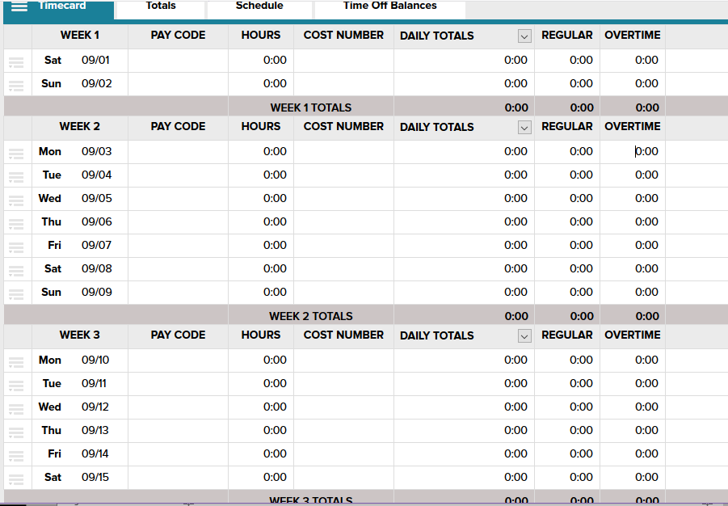

**Entering Your Non-worked Time via Time & Attendance**

To enter non-worked time such as vacation, sick, or personal time, follow these steps.

**Starting Point: Myself > Time & Attendance > My Timecard**

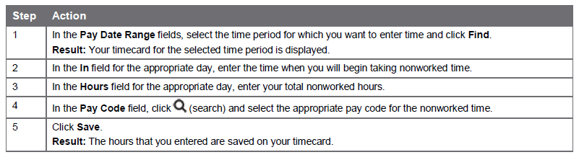

**Adding Notes to Your Timecard**

You can add notes that apply to individual transactions and rows or to the entire timecard. Your supervisor and Juniata’s HR & payroll offices may view all of the notes that you enter.

**Adding a Note to a Timecard Transaction or Row**

**Starting Point: Myself > Time & Attendance > My Timecard Action**

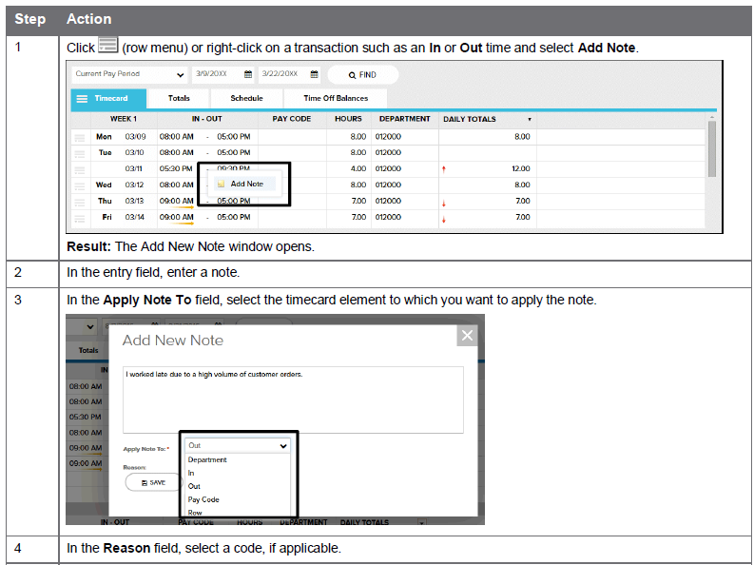

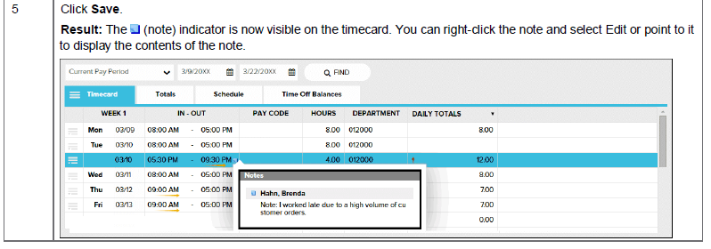

**Adding a Note to an Entire Timecard**

**Starting Point: Myself > Time & Attendance > My Timecard**

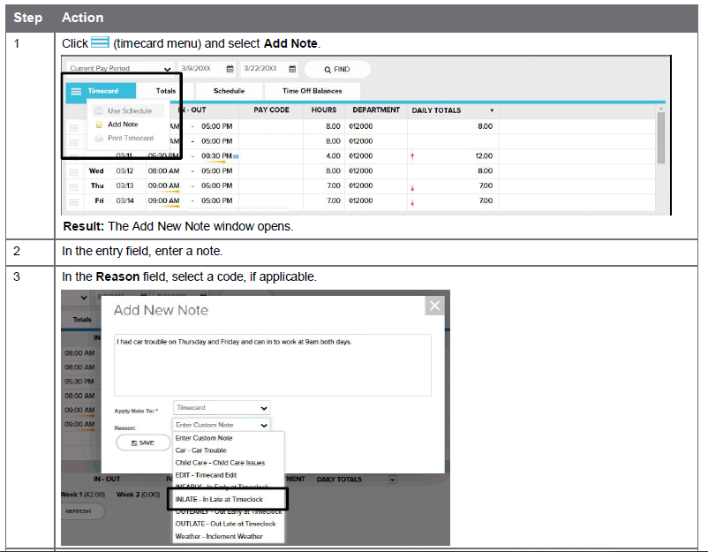

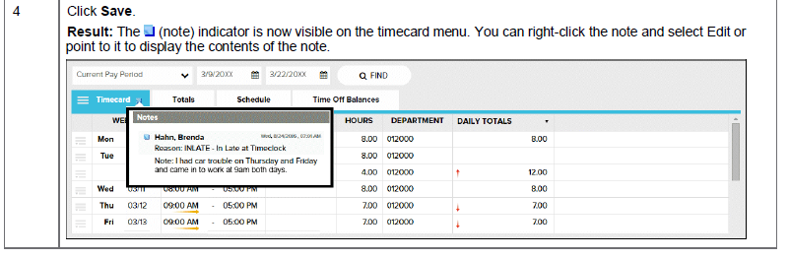

**Viewing and Printing Your Timecard**

**Starting Point: Myself > Time & Attendance > My Timecard**

