Assessment Summary for Social Sciences “S”
2014-2015
General Education Goal Assessed: Develop knowledge about and ways of understanding the world: social science

Curriculum Definition: Social Science: Social scientists strive to understand a wide range of human behavior, from the formation of the self to the interaction of nations. Knowledge is acquired from systematic study, using a diverse set of scientific methods including laboratory experiments, field observation, survey work, and quantitative and qualitative ethnographic analyses, as well as insight acquired through experience.
Focus of the Assessment
One-hundred level courses with “S” designations from Fall 2005-Fall 2015 were gathered to better understand social science course offerings and patterns of student enrollment in these courses.
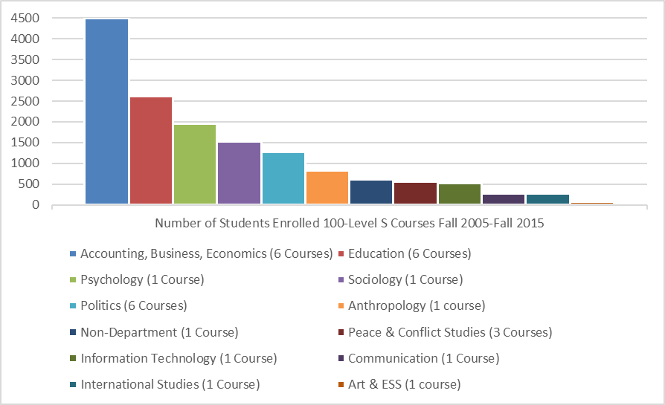
Twenty-nine 100-level “S” courses across eleven academic departments were identified. The departments of Accounting, Business, and Economics, Education, and Politics each housed six different 100-level courses, while the Peace and Conflict Studies program housed three. The remaining departments/programs (Information Technology, International Studies, Sociology, Anthropology, Communication, and Psychology) each housed one 100-level course. One course was cross listed across the departments of Art and Environmental Science and the course Career Planning, offered by the Career Services office, was the only non-department “S” designated course.

To better understand student enrollment in these courses, enrollments from the 100-level “S” courses between Fall 2005-Fall 2015 were examined.
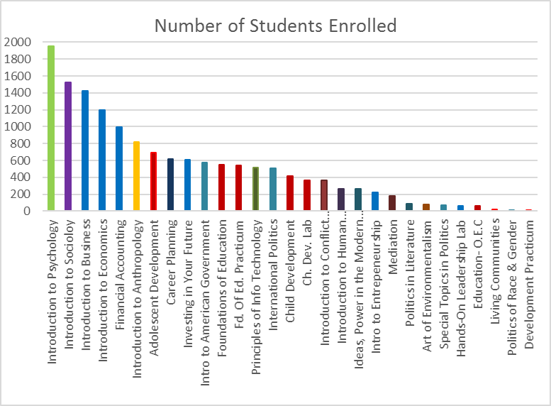
Across these 19 semesters, a total of 1,950 students completed PY 101: Introduction to Psychology. The next highest enrollment courses were Introduction to Sociology (1526 students), Introduction to Business (1426 students), Introduction to Economics (1193 students), Financial Accounting (993 students), and Introduction to Anthropology (819 students).

As suggested by Ms. Linda Suskie, an assessment consultant, we began to explore the learning outcome knowledge about and ways of understanding the world by investigating student learning in the most enrolled courses. As a result, this assessment report focuses on student learning in PY 101, Introduction to Psychology.

According to the class description, the Introduction to Psychology course provides an introduction to the scientific study of mental processes and behavior. Students are provided with an overview of theories and research from various domains in the field of psychology such as: cognitive psychology, developmental psychology, biopsychology, social psychology and abnormal/clinical psychology. During the course, emphasis is placed on how psychological theories and research influence daily lives of individuals, groups, and our larger society. Additionally, professional opportunities in the field of psychology are discussed.

The course syllabus outlines the following learning outcomes.
Upon completion of this course it is expected that students will:
- Understand psychology as an empirical science that is based on critical thinking
- Understand that psychological knowledge is dynamic, not static
- Have an increased awareness of the breadth and diversity of the discipline of psychology
- Understand how the various sub-fields of psychology are interconnected and integrated
- Have an increased awareness of professional opportunities in the field of psychology
- Understand that events/situations do not occur in isolation, but rather are influenced by numerous factors which may include biological factors, personal factors (beliefs, desires, feelings), and social, cultural or environmental factors
- Understand how findings from psychological science apply to everyday life
How did you collect your data (method and tools)?
The definition of social science adopted by the Juniata faculty is:
Social scientists strive to understand a wide range of human behavior, from the formation of the self to the interaction of nations. Knowledge is acquired from systematic study using a diverse set of scientific methods including laboratory experiments, field observations, survey analyses, quantitative and qualitative ethnographic analyses, and insight acquired through experience.
An initial review of this definition in terms of student learning outcomes revealed notable limits. First, the definition is broad, with no clear articulation about what students will know or be able to do after completing “S” designated courses. The focus of the definition is general in terms of “understanding human behavior” with no clear identification of the role of social science theory in informing this understanding. In addition, the definition outlines various research methods and types of data collection used by the social science disciplines, but as stated previously, does not clearly articulate expected student knowledge and/or application of these methods. The limits of this definition made assessment of student learning in “S” courses difficult. Consequently, to better understand the scope of social science learning outcomes, various definitions of social science were examined. From this review of ten definitions, the following core social science themes emerged:
- Major concepts, theories, principles to describe human experiences and behavior
- Methods of systematically evaluating questions related to human experiences and behavior (research design)
- Methods of manipulating data related to questions raised to understand human experiences and behavior
- The roles of individuals in cultural, social, economic, and political worlds

For the purposes of this assessment, these four core themes of social science were adopted as representing core content of social science courses.

Introduction to Psychology exams from two semesters (Fall 2014, Spring 2015) were reviewed for the frequency of these social science themes among the exam items. For each of the four, 50-item multiple choice exams each question was examined and categorized under one of the four social science themes. In addition to social science theme, the level of student learning according to Bloom’s Taxonomy (Revised 2001) was explored. Each of the exam questions was categorized under one of the following three levels of the taxonomy: remember (recall facts and basic concepts), understand (explain ideas or concepts), and apply (use information in new situations).

A total of 208 exam questions (8 questions differed on the exams across the two semesters) were coded by 2 raters for: 1) Social Science Theme Area, and 2) Bloom’s Taxonomy. Inter-rater agreement on the classification for both social science theme and Bloom’s learning level was 91%, which represents a high rate of agreement. When there was disagreement, the items were reviewed and the raters reached consensus on a final rating.

To understand student learning in these areas, the percentage of students correctly answering each exam item was then calculated. The percent correct was identified for both social science theme and Bloom’s taxonomy learning level.

Outline the results of the assessment:
The results of the exam question classification revealed that the large majority of the exam question reflected the social science theme of major concepts, theories, and principles to describe human experiences and behavior (87%). With 13% of questions reflecting the social science theme of research design. The remaining categories of manipulation of data (statistics) and role of individuals in cultural, social, economic, and political worlds each reflected less than 1% of the total questions respectively.

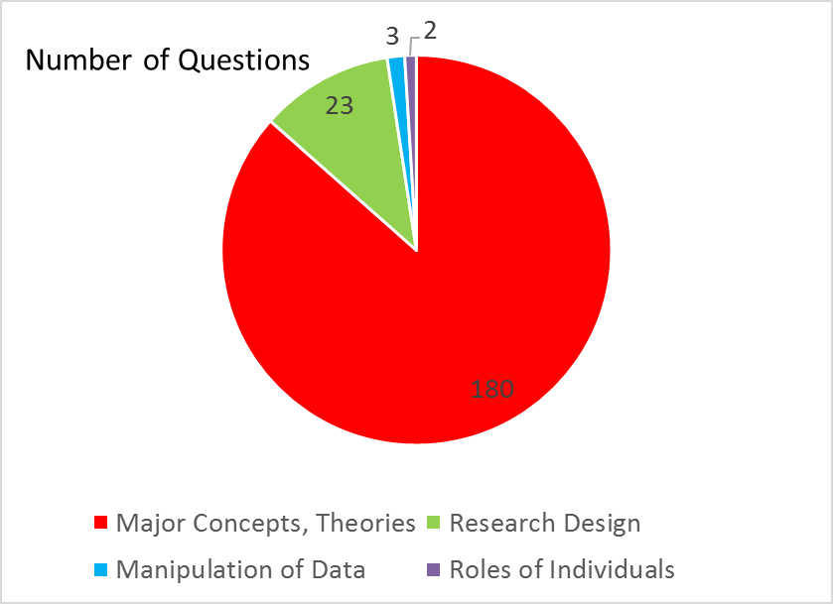

In terms of level of student learning, all the exam items were categorized under the first two level of the taxonomy. According to the rates, no items reflected application as outlines by the 2001 revised taxonomy. The majority of questions across the four exams were categorized as Understanding (155 questions) with the remaining questions falling under the category of Remembering (53 questions).

To examine student knowledge in the social content areas, the percentage of students who answered each questions was calculated. Overall, performance across the exams average 74% (range 72%-77%). By level of learning according to Bloom’s Taxonomy, students’ performance on categorized as reflecting Knowledge was similar to that of the items categorized as Understanding.

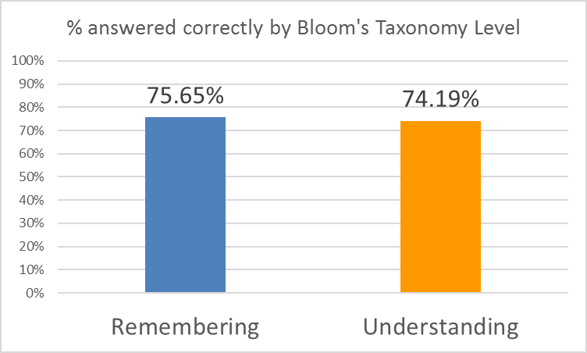

Students also performed consistently across the four social science themes.

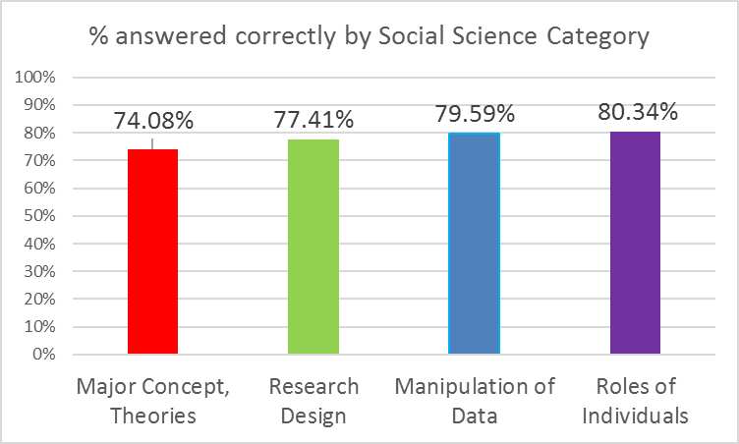

Analysis: How do you interpret the results? What does it mean?
The data identify that student assessment in this 100-level “S” course is heavily focused on the major concepts, theories, and principles that describe human behavior, with 180 of the 208 exam items reviewed falling into this social science theme. Thirteen percent of exam items reflected student knowledge and understanding of research methods. Very few exam items reflected manipulation of data (e.g., statistics) or understanding individual roles in cultural, social, economic, and political worlds. The review of exams also identified that students are asked to be able to explain or use ideas or concepts (Bloom’s Understand) more frequently than they are asked to recall or recognize (Bloom’s Remembering). On these assessments, students are predominately required to demonstrate a higher level of learning than basic recall or recognition of facts or terminology. Overall, students’ performance on these in-class exams demonstrate that they acquire an adequate level of knowledge and understanding of the four social science themes.
Based on the analysis of the data and synthesis of information, what are next steps? Be sure to include an explicit timeline for next steps.
Currently, we do not have an effective manner of mapping what courses students take to complete the general education curriculum goal of “develop knowledge about and ways of understanding the world” as it relates to our liberal arts distribution of FISHN. Because of this, we do not have a clear understanding if the students enrolled in this course were completing the “social science” distribution requirement. With 29 introductory (e.g., 100-level) social sciences courses, students are likely having a notably varied experience with this curricular component. Whether or not this diverse academic experience results in similar outcomes will need to be explored.

Relatedly, the current definition of social science is notably broad and provides no clear outcomes for student learning. The attempts to identify core themes of social sciences should be further explored and developed across disciplines in the social sciences. Once a comprehensive identification of core themes of social sciences occurs, clear learning outcomes can be established. A next step in identifying core themes in the social sciences could be to replicate this assessment with other social science designated courses. Namely, examining student work in Introduction to Sociology, Introduction to Business, and Introduction to Economics (the next three highest enrolled courses across the past 10 years) to see coherence to (and deviation from) these core social science themes would be helpful. Examining the outcomes of student work in these courses related to these social science themes also would help to articulate student learning in these 100-level “S” courses and provide a broader view of student learning in “S” courses.

Committee Members
Kathryn Westcott, Shayna Yeates, and Mark McKellop

