Fact #1: Winter Break Closing & Check-out  All students must vacate college housing within 24 hours of their last final (but no later than December 16 at 10:00am).  Let us know when you plan to leave!  Insert QR Code Here:  Please complete the form by Friday, December 8th.  Not returning after this semester, please:  - Notify the Dean of Students Office of your intentions.  - Schedule a time with your RA to check out. | Fact #2: Winter Housing  Do you need housing for the winter break? Do you need to come back early (i.e. sports team, student teaching, etc.?  Please complete the “Winter Housing Application” on Eagle’s Nook.  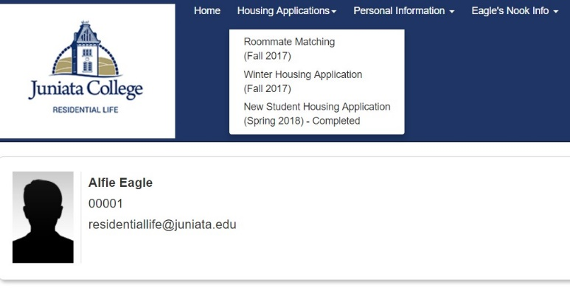  Please contact ORL for instructions on how to access the application.
Fact #3: Extended Quiet Hours  24 Hour Quiet Hours will begin Friday, December 8 at 11:00pm through Saturday, December 16.  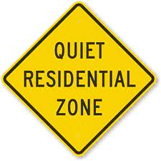 | Fact #4: Tips For a Successful Closing  - Clean and unplug mini-fringes.  HINT: Defrost your refrigerator one day prior to departing and leave the doors open. Place a towel under to soak up melting ice.  - Remove all items from windowsills.  - Unplug all appliances  - Close and lock windows; close curtains/blinds.  - Remove all valuables, including cash and checkbooks.  - Remove plants and pets to protect from lowered temperatures.  - Dispose of all trash, recycling and perishable food items.  - Turn off all lights.  - Lock doors.  - Lock your bike on the bike racks.
If you have any questions, please contact the Office of Residential Life!

