Juniata Study Abroad Application Through Terra Dotta
Terra Dotta is a third party system that allows us to organize and provide information on study abroad programs to students and others who will assist the students in making their decisions. It is an on-line system that manages the application for study abroad and the student application materials.
In order to request a recommendation from you, the student will search for your name in the directory that is linked to Juniata’s Datatel system. We are strongly emphasizing to students that they should speak with you before simply generating the email request. The students are required to provide you with a copy of their essay if you would like to review.
Students are asked to select a program of first choice and a program of second choice which will generate two separate requests for a recommendation. As a recommender, you are only be asked to submit one recommendation for each student. After you complete one recommendation for a student, we will manually update the application for the program of second choice with the recommendation materials.
1) You will receive an email from studyabroad@juniata.edu that is clearly marked Center for International Education – Recommendation Request.
You go to the link, enter the last name of the student (Timney in the example below) and copy/paste the long ID number. Be careful about any extra spaces when copying the number.
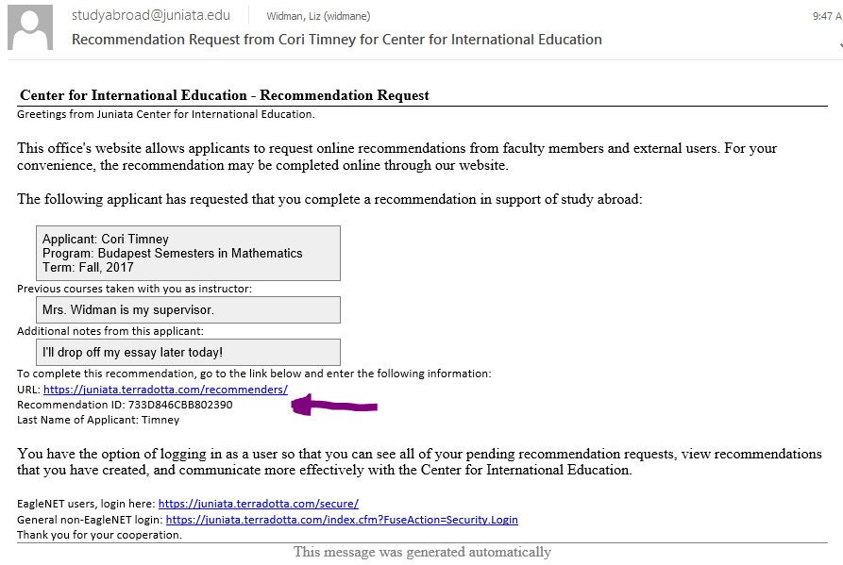
2) You can log in individually for each request received or you can log in using your Juniata username and password. That link is shown at the bottom of the email for the individual request. Your recommender mailbox in Terradotta shows all outstanding requests for recommendations. Note that you can look at closed ones to see what you’ve done. You click on the student name to look at the recommendation.
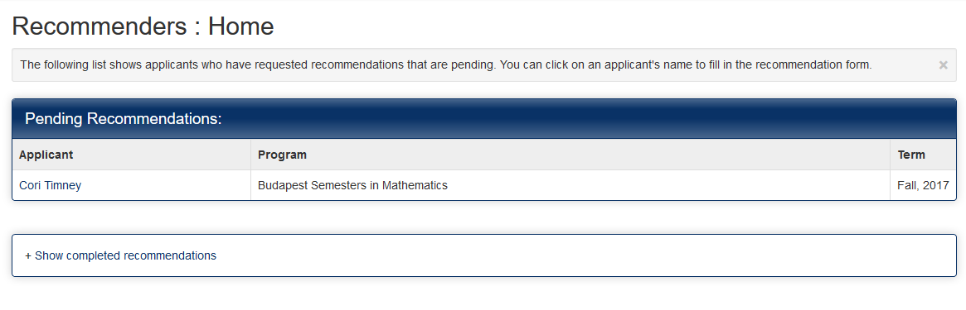
3) The recommendation forms that are on-line with Terra Dotta are the same as wat you have used in the past. Most blocks will require an answer of some kind. The next page shows the recommendation starting in the middle. Question #9 is where you can say yes OR you can attach a word document in which you might add additional comments. We recommend using a word document because there is no SAVE button. You will want to have a document ready to attach (by clicking the yellow file folder icon). This page will time out at 59 minutes and will not save.
